My Career Choice

By

Yeykin Valenzuela

IT 110C

IT in the Global Age

Marymount University

Introduction 3

Occupation Fit, Skills & Interest 4

Occupation 5

Education & Training 5

Pay Scale 6

Notable Person 7

Journals/ Associations of Interest 7

Conclusion 8

Table of Figures 9

Works Cited 9

# Introduction

The time has arrived. The time to decided which path someone needs to take, and hopefully, that will be the right one. When in college, students are excited to start a new page in their lives, but there’s that period of time when everything turns around and make them realize that college is not just about fun. During Junior and Senior Year, students need to have an idea of what they want to do next with their lives. There are students that already have planned what to do after college for example; where to work, what position they want etc. But, there are also students that are scared about giving the next step because they have no idea of what to do.

In this paper, I will describe My Career Choice and how I plan to achieve it. I will also name a Notable person in the Occupation I have chosen. My choice may not be clear, but it is all I have and it’s all I need for the moment (at least I’ll like to believe so)

## Occupation Fit, Skills & Interest

Since I was little, I have always like to be in charge of things and guide people to accomplish such task. There were times when the decision of choosing what to do next affected my passion. There were so many questions that rose when planning for my future such as: Job opportunity, Payment desire, how much will I like this job? Is it what I want to do? am I making the right choice?

When I got to college and got myself involved in activities that I was in charge of, the feeling came back. The feeling of knowing what I wanted to do, the feeling that I have forgotten throughout the time. The feeling of being someone who can guide others the achieve a goal in common.

In order to accomplish my goal, I had to developed skills that will be suitable for my desired position. Nowadays, I am a person that is able to communicate smoothly, I am professional when it’s needed, I put my job before myself, but I also balance my job and personal life. I work very good under pressure, I’m a team player, open minded, listen to new ideas, delegate etc.

Throughout my other jobs and volunteer experience, I have learned to approach differently to different people because it is known that every person is different and everyone has a different way to be approached.

### Occupation

I always wanted to be in charge of things and people. Therefore, I want to be a general manager, thus, I am managing on Business management. This is what I want to do, but I’m also open to new opportunities and try new things. I want to do small projects before having the position I desired. This is why, I want to learn what to do, when to do it, and how to do things. I want to learn what’s needed by being in contact with people around me, which I will be in charge of.

### Education & Training

The necessary education and training I need for this occupation is: Go to masters because I want to have deeper information in the area of management. Undergraduate will prepare me and will give me an idea of what my job will be like, but I believe Graduate school will be closer to what I want to do. As Aurelio Locsin said in “General Manager Requirements,” a “Bachelor’s degree in business administration or a field related to their work (2018)” will be enough. He also stated that General manager need to have certain leadership skills such as: being able to coordinate resources such as money, time and people. Problem solver is also important, good communicator and finally they must be organized and responsible (Locsin, 2018).



Figure 1

#### Pay Scale

According to the PayScale website, a General manager with 1-4 years of experience can earn up to $83,000 (including tips, manufacturing and bonus) (2019). These wages can increment according to the experience and responsibilities someone holds.

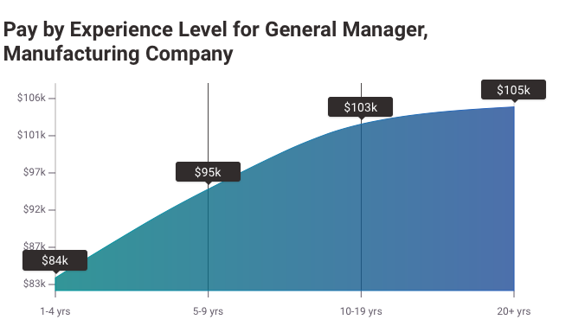

Figure 2

##### Notable Person

I have a notable person that made me realize what I want to do and what I can do better. I am currently working and my general manger has just graduated from school and was in charge of his father’s business. He was a nice person, but was not an excellent manager due to the issues that were caused due to his delegations. One year after he managed the business, it was sold due to lack of revenues and profits. But the new company that bought it is producing better revenues, and it can be said by observing the change difference on customers purchases and the more frequent visits to the business.

He might not be someone to inspire me to be like him, but he inspired me to be someone who can be better than him and pay attention to the areas he did not.

Journals/ Associations of Interest

I have not looked into a suitable place to work at, but since I was little I wanted to work at a bank doing management work. Some of me far cousins have worked at banks and I think this is why I got an Idea of it. So, for now the only idea I have is to work at a Bank of America, since I do not have a lot of knowledge on American Businesses.

Bank of America’s vision statement is “to help make financial lives better by connecting clients and communities to the resource they need to be successful (Johnson, 2019).” I think their mission statement and values fits into my interest by creating communities within customers so that they can achieve a common goal. We all want to be successful and want to have a better life, this is what I want to help others achieve.

Conclusion

College is the time when one of the most important decisions have to be made, what to do after graduation. Some already have a plan, but others have no idea of what to do. People have certain qualities and skills that make them suitable for specifics jobs. For a General Manager, they’re specific skills that I need, which I am and will keep acquiring throughout my college experiences. It will take time and doubts will arise, but it all depends on me. If I want to do it and I desire this position, I will work hard until I accomplish it and once I accomplish it, I will work even harder to improve it and do my best.

Table of Figures

[Figure 1 6](applewebdata://3D54901C-5901-4613-A1E8-474E0E34E006#_Toc19442606)

[Figure 2 6](applewebdata://3D54901C-5901-4613-A1E8-474E0E34E006#_Toc19442607)

# Works Cited

Johnson, R. (2019, 06 21). *Bank of America's Corporate Mission & Vission Statement*. Retrieved from Rancord Society: https://www.rancord.org/bank-of-america-mission-statement-vision-statement-strategic-analysis

Locsin, A. (2018, 07 01). *General Manager Requirements*. Retrieved from https://work.chron.com/general-manager-requirements-10599.html

PayScale. (2019, 08 13). *Average General Manager, Manufacturing Company Salary*. Retrieved from https://www.payscale.com/research/US/Job=General_Manager%2C_Manufacturing_Company/Salary